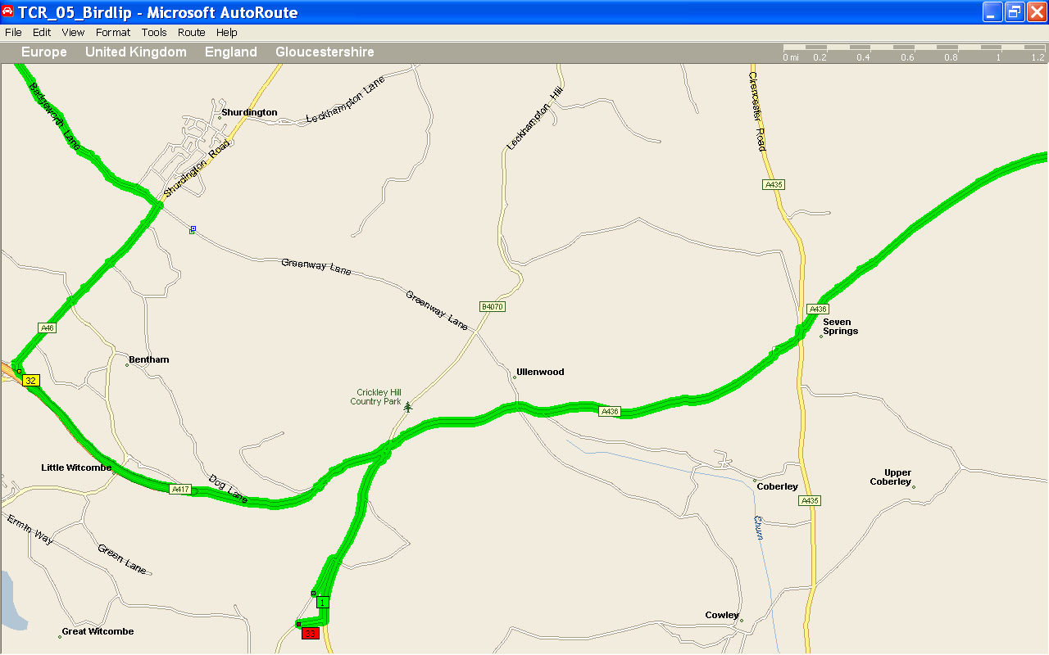

Start off from Birdlip Viewpoint, head towards the Air Balloon Pub R/A.
Follow the A436, and signs for Andoversford.
Staggered crossroads of A436 / A435 could cause problems.

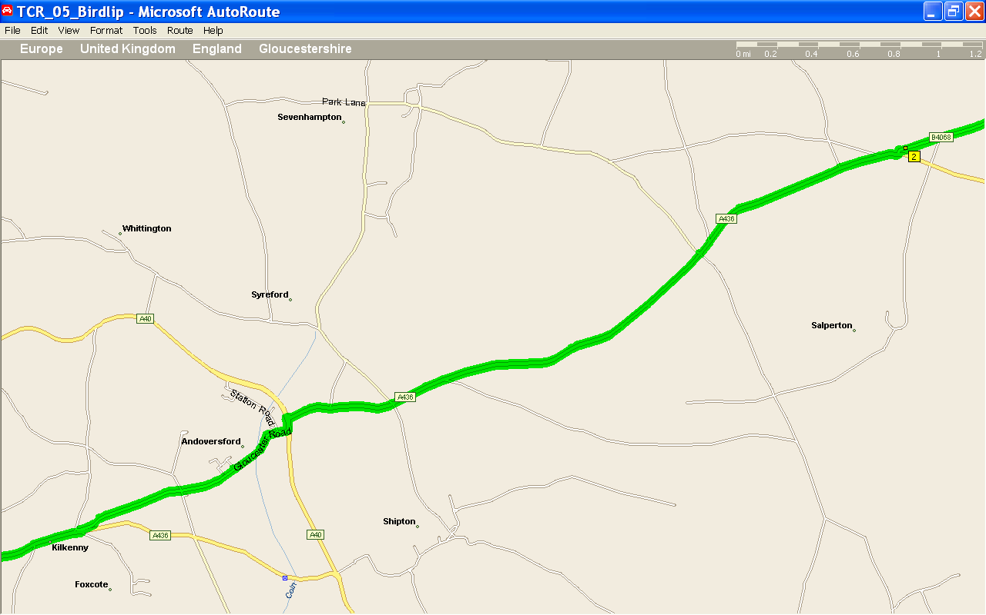
Follow signs for Andoversford, taking a left off the A436 (Pub on Left hand side).
Out of the Village, staggered crossroads then Back onto A436.
A40 / A436 staggered crossroads has traffic lights aswell so may cause problems.

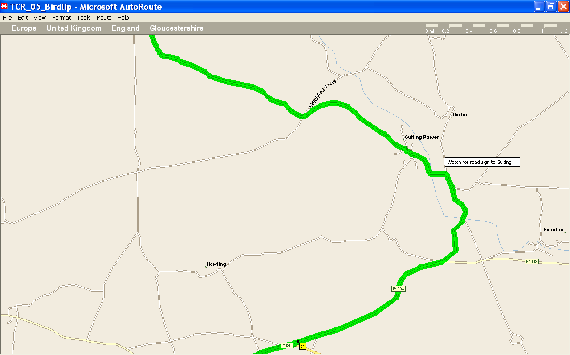

Left turn off A436 onto B4068, after 1 ½ miles left turn onto local roads(B&B on corner I think), then follow signs for Guiting Power

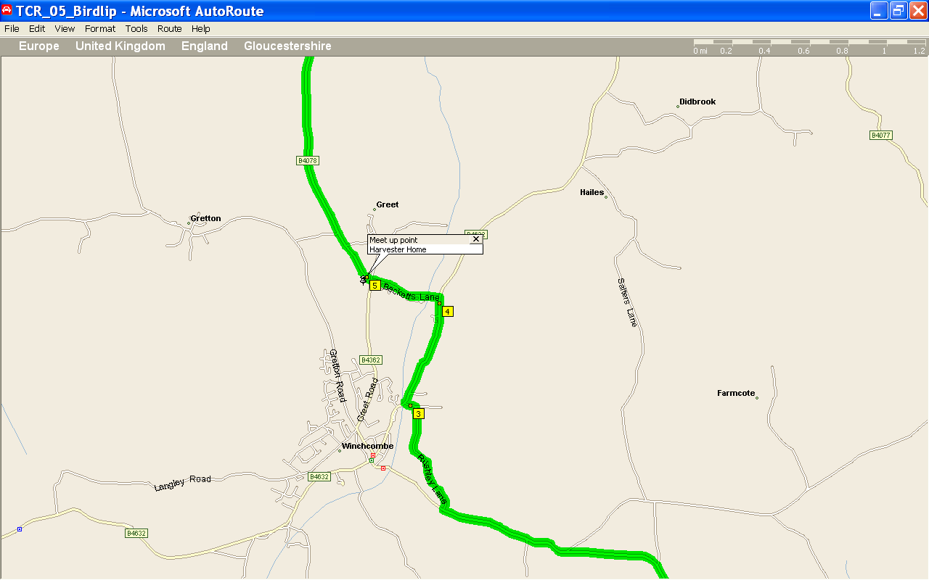

Point 3 could be a bit of a nightmare if there is any traffic.

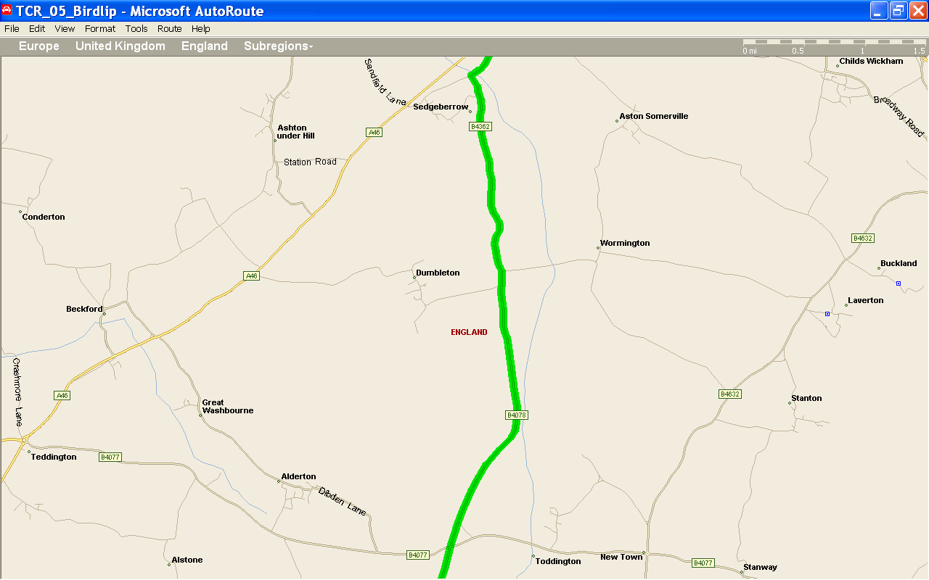

B4077 has right of way at the cross roads, CAUTION exiting junction - limited visibility to left.

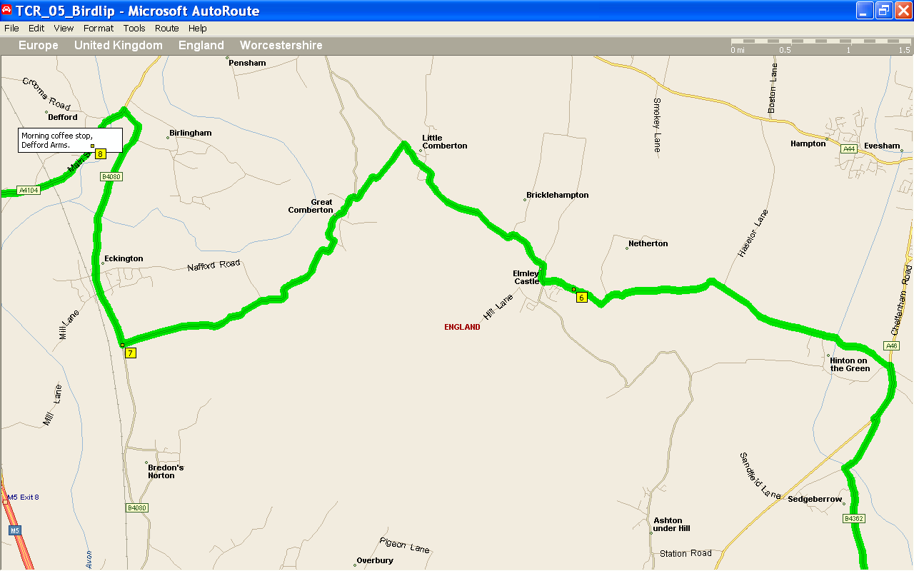
Crossing the A46 shouldn’t be too bad, follow signs for Elmley Castle. Just after crossing A46, there is a short straight which you could use to bunch people up / make sure everyone has made it (as long as Joe Public doesn’t get caught up!)
Then follow signs for Great Comberton and Eckington – although after Great Comberton, near Woolla’s Hall keep straight Don’t take the turning signed for Eckington!!!!
Turn right onto B4080, and at the end left onto A4104. Defford arms isn’t too far away.

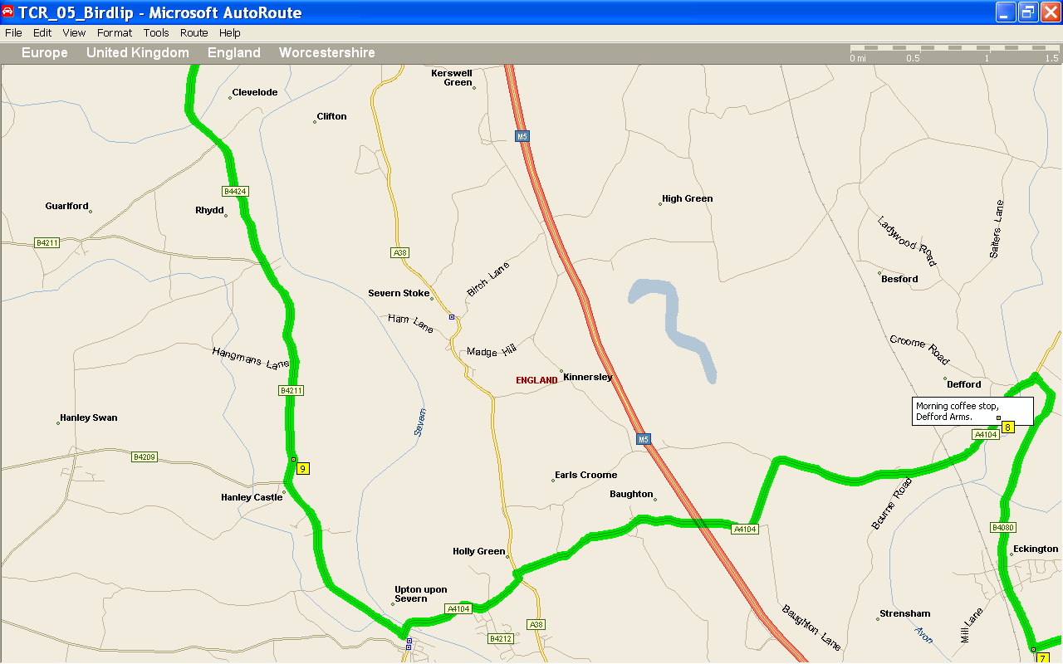

After coffee, follow the A4104 heading for Upton on Severn , there is a staggered crossroads to cross the A38.
Follow signs for B4211,and B4424 (don’t head for anything with Malvern in the title!!)
There is some construction work just before Upton, with traffic lights, if bunched up shouldn’t be a problem.

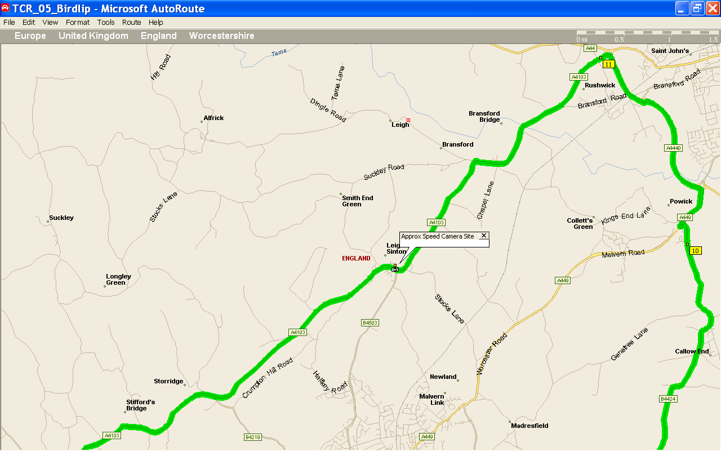
Just after point 10 on the map, strange island / junc. Need to follow A449 Worcester., then left onto A4440, then follow signs for A4103 (Hereford).
In the village of Leigh Sinton is a sneaky speed camera staring at you as you round a bend – Limit is 30.!!

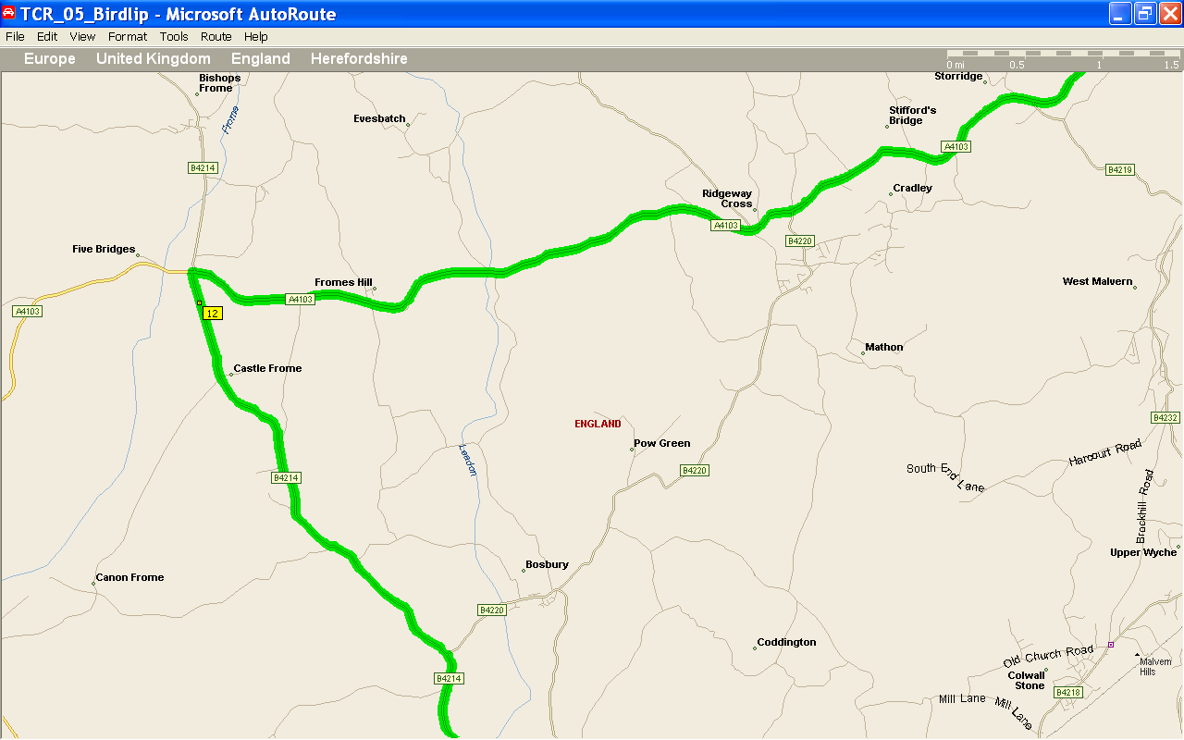
Keep on the A4103 until you see signs for the B4214, left turn – it being on a down hill and a bit over 90° turn its easy to go wide!!!

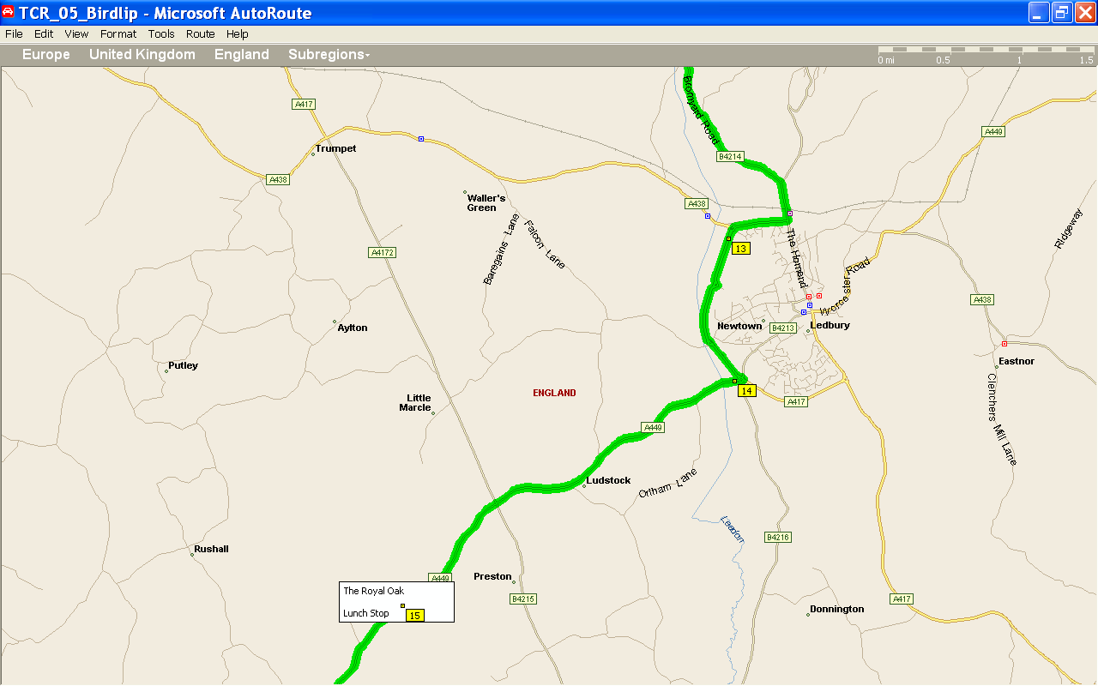
Depending on time, can either take the route as planned (by-pass) or go through Ledbury town Centre – quite nice, and shouldn’t cause any delay.
Will need to follow signs for Ross on Wye.
Pub is on the right hand side, car park after the Pub.

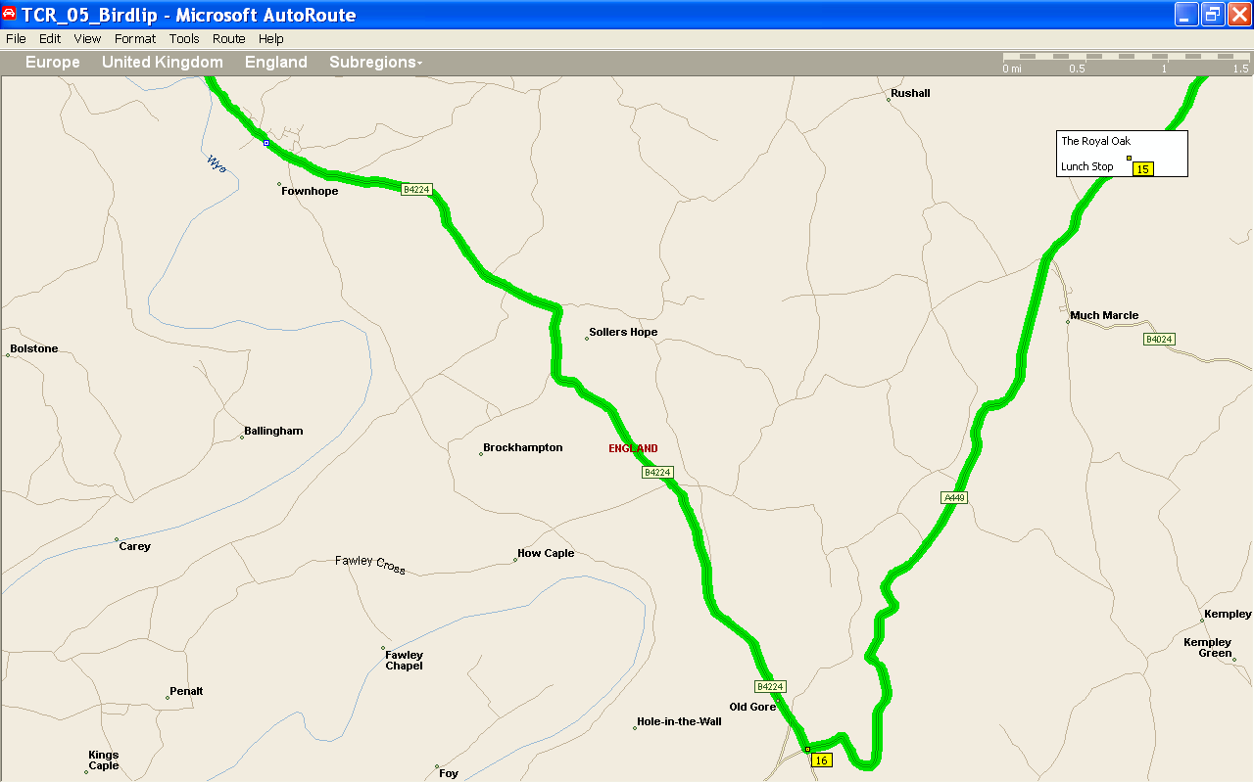
There is a very nice loooonnnnggg straight after the turning for Much Marcle, time for the loud pedal!!!
But after that, if there is traffic in front its best to hold back and let them get at least a mile in front, there are some cracking twisties and it won’t take long to catch the traffc again – following a Micra at 20mph is soul destroying!!

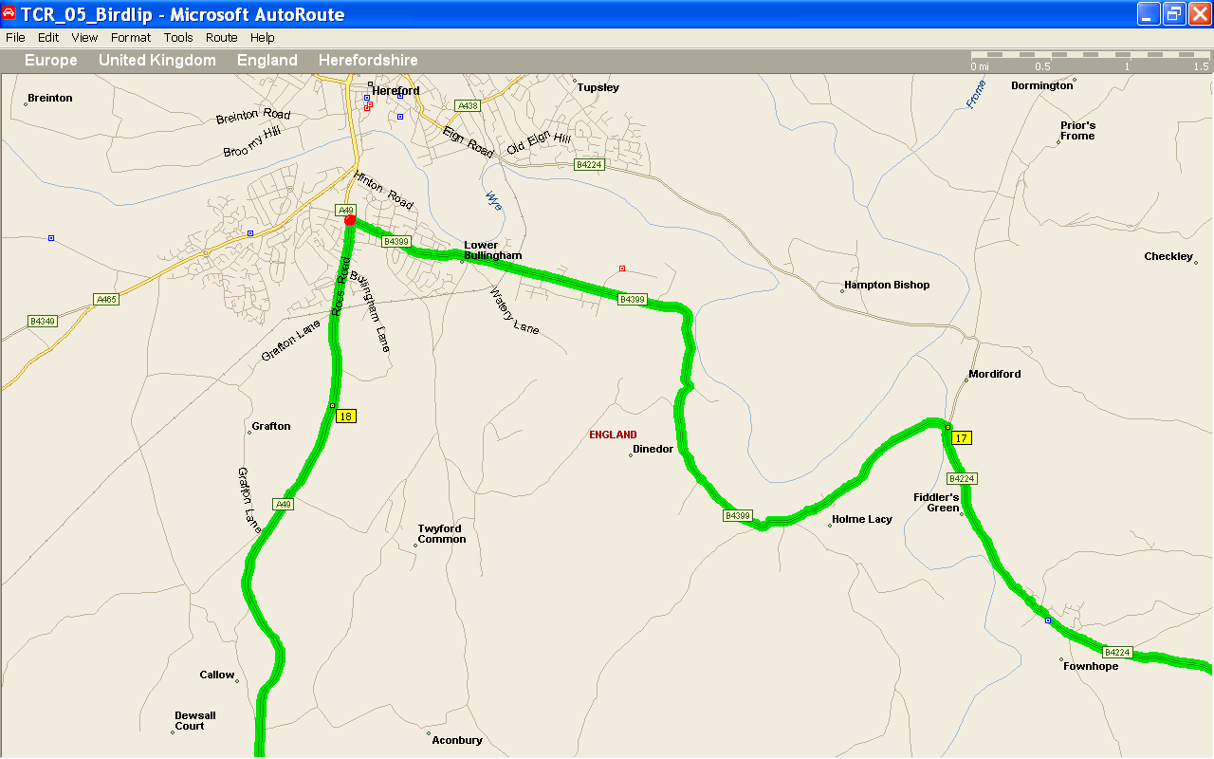

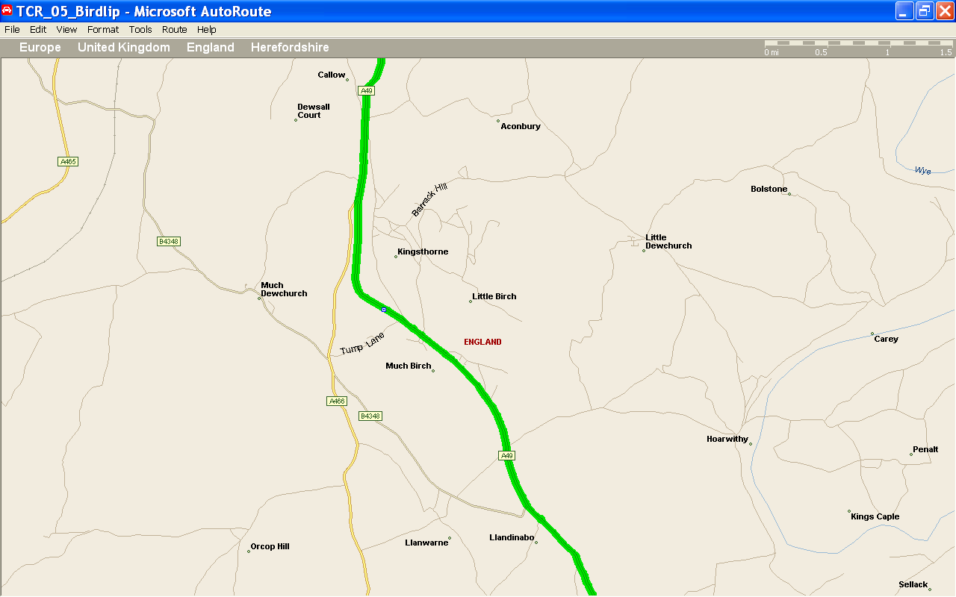

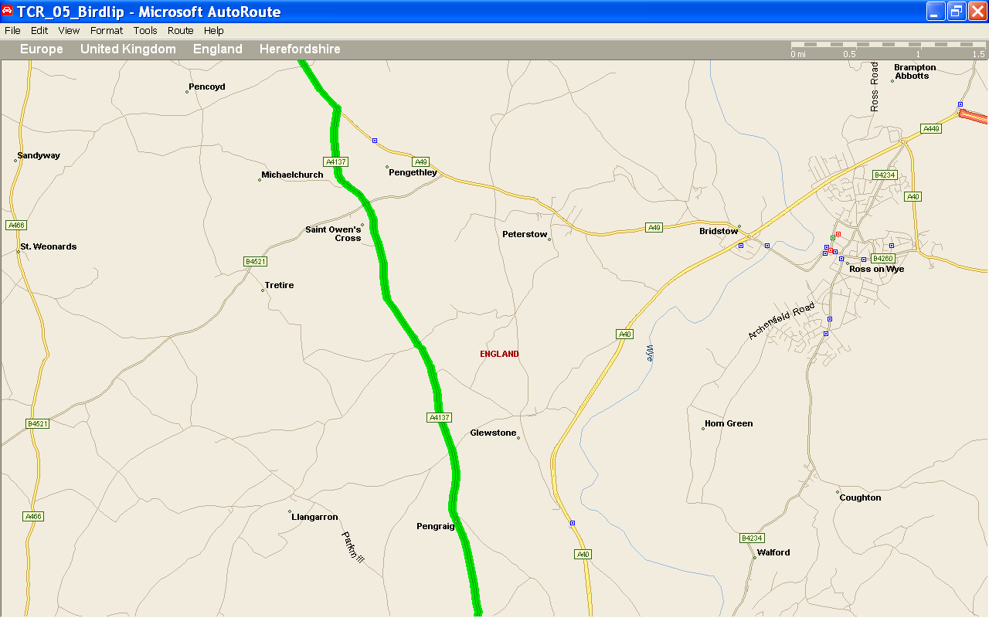

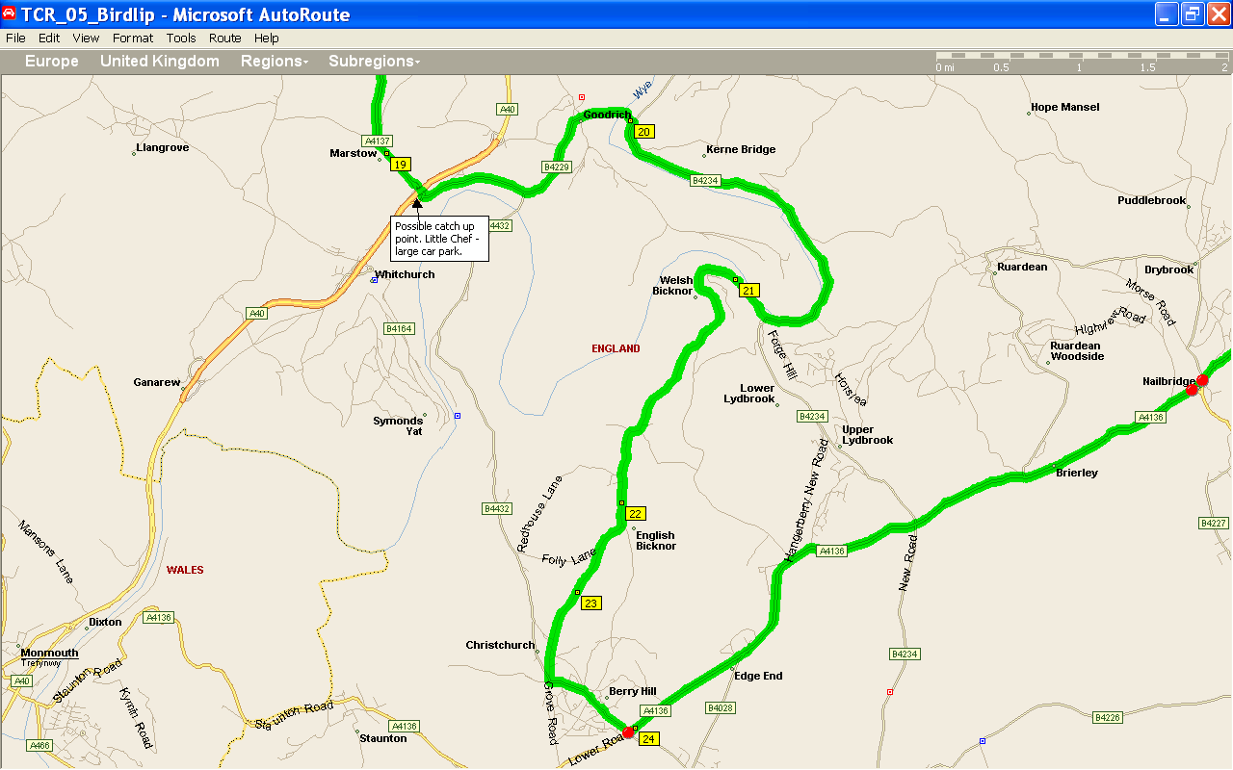
There used to be Little Chefs either side of the A40 (just after point 19), the Northern one has closed down – but they both have big Car parks that could be used as catch up points, need to let people know in advance if you’ll use it – might not see the Tivs down in the car park and drive on by!!!
Tried to find a nicer way from point 22 onto the A4136, but it’s all single track stuff.
So, you will be looking for signs to Berry Hill, turning is on the left – just after a Church. (Park Road). Follow this until a crossroads with Traffic lights, then left onto the A 4136. Lights may split the group. No big lay-bys near!?
Brierly has some laybys / pub car park that you maybe able to use to re-group. (I have also seen a mobile speed camera here before – 40 limit)

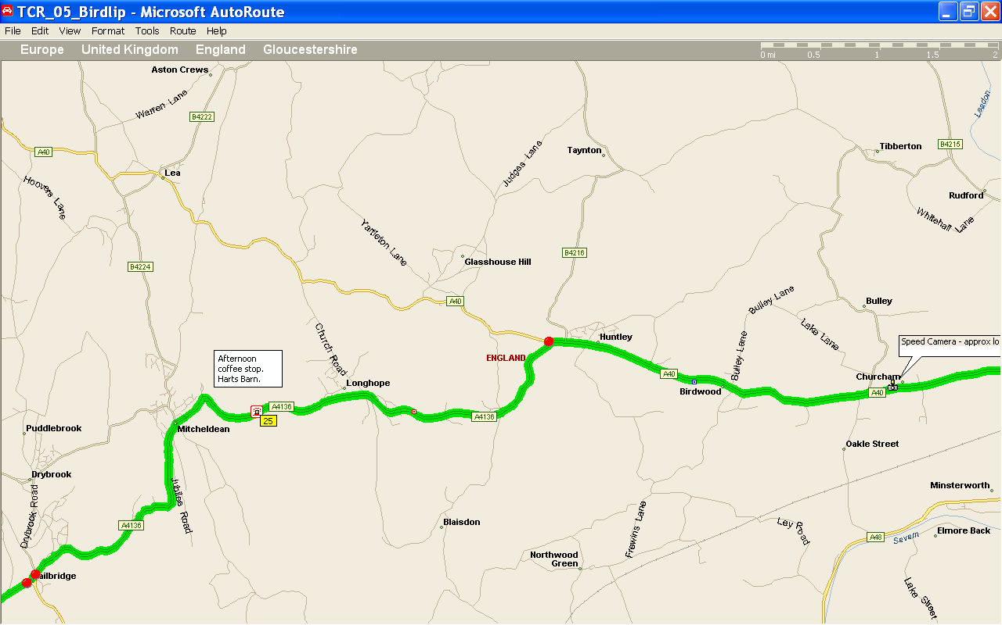

Two sets of lights at Nailbridge, just keep fingers crossed for Green!!
Harts Barn is not far after Mitcheldean, and has Brown Signs pointing you in the right direction, another down hill tight left turn – start to slow down at the first Brown Sign!!!! Car Park at top and bottom (signs pointing to disabled parking also has normal spots)
Junc of A4136 and A40 has traffic lights, so another potential split point – unless timed right!!
Speed camera on A40 – think its in Churcham, can’t remember exact spot. Not hidden though.

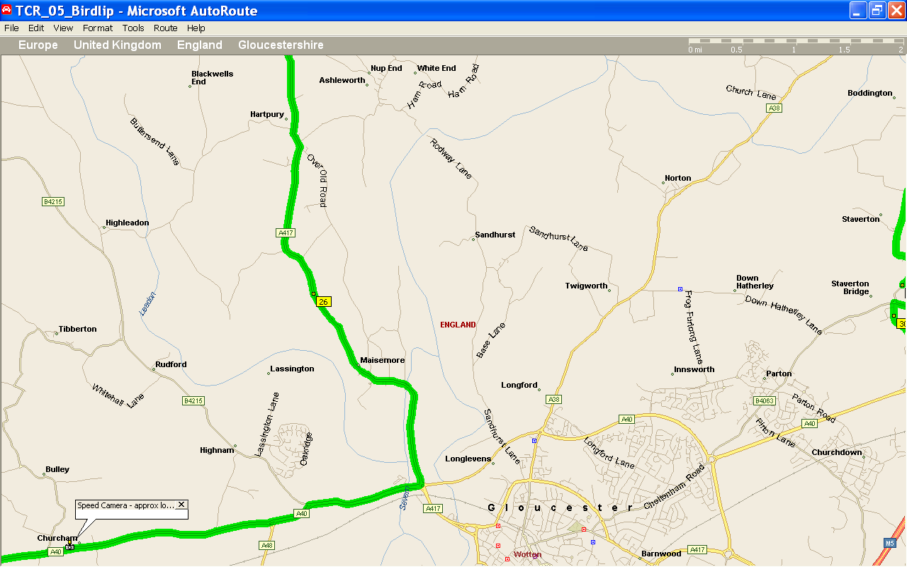

From A40, take left at R/A onto A417 – I have seen mobile speed camera in Maisemore!! Possible pub for Wed night meet on RHS???

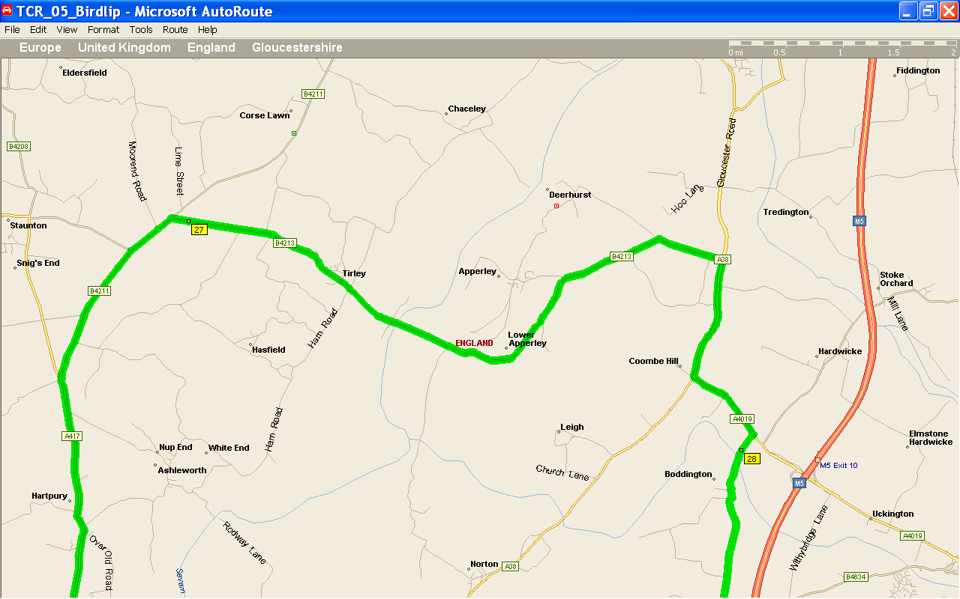
BP garage just before B4211 turning – but a bit expensive. (pointed out this garage cos I’m sure it would have 97/98 Ron)
Another possible Wed night meet Pub in Lower Apperley, or close by, called the Farmers Arms (RHS).
Also, the Swan Inn – Coombe Hill, junc of A38 & A4019 looks like it’s just been done up – and has a large Car park.
Need to take a right off A4019 – sign posted for Boddington.
Traffic lights at junc of B4213 & A38, but can bunch up before, Dual Carriageway afterwards

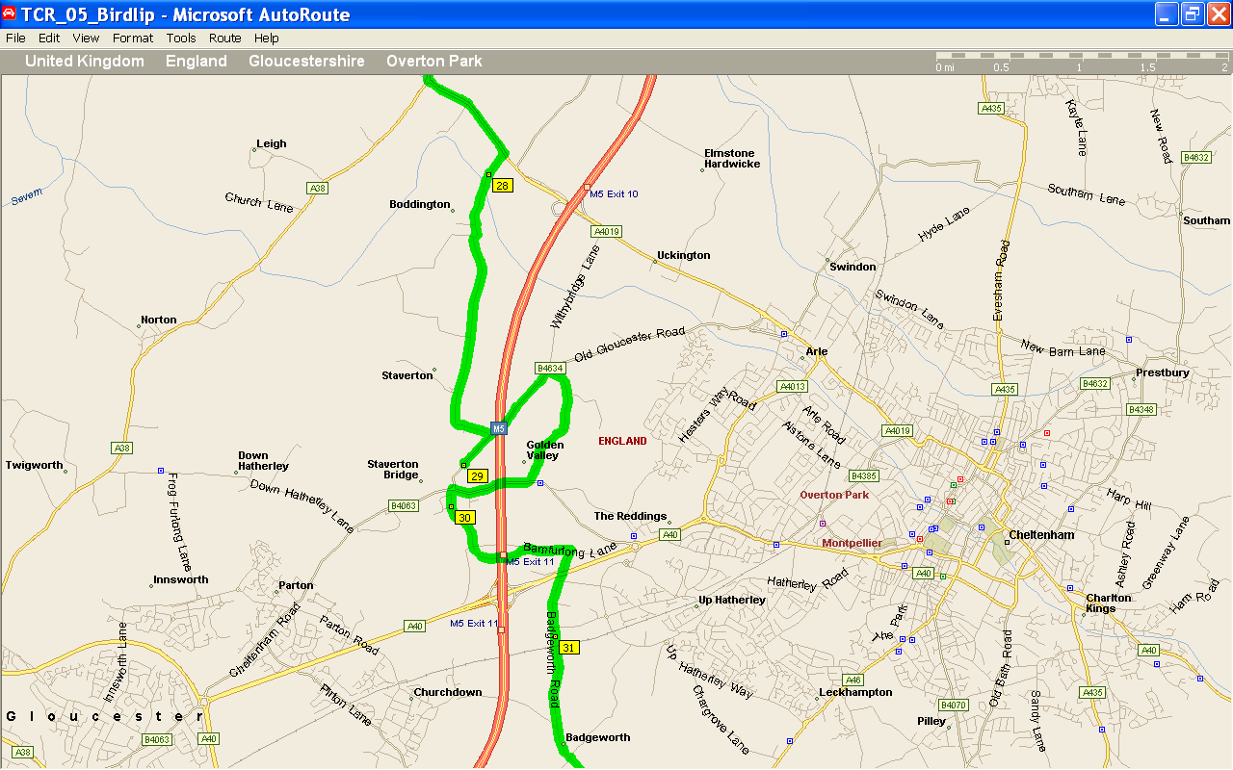
OK, Auto route won’t play the game here. I want to go from point 29 to 30 – straight over at a set of lights.
Be careful turning right onto B4634, fast road for cars crossing the M5.

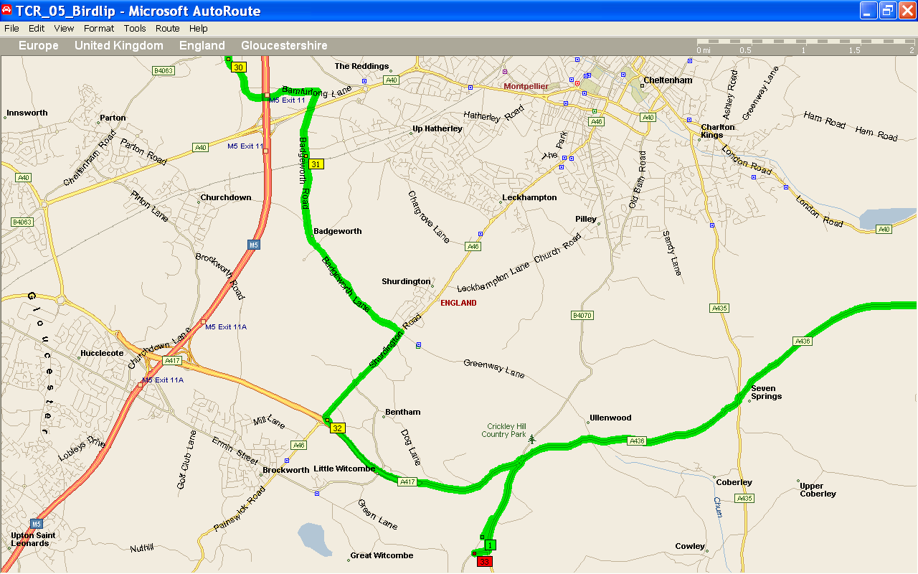

I’ve put the finish as Birdlip, not sure what people will want. Did plan for drinks at Puesdown, but that was before inserting the coffee break.

